**DBSCAN Algorithm:**

It has min points and epsilon(radius) as hyperparameter.

Algorithm:

1. For each point in a data set, label it as core point, border pt or noise pt.

To find the label of point we use range query whose input are point, data set and epsilon,

And this range query return set of all points within eps to that point.

Internally range query is implemented using kd-tree.

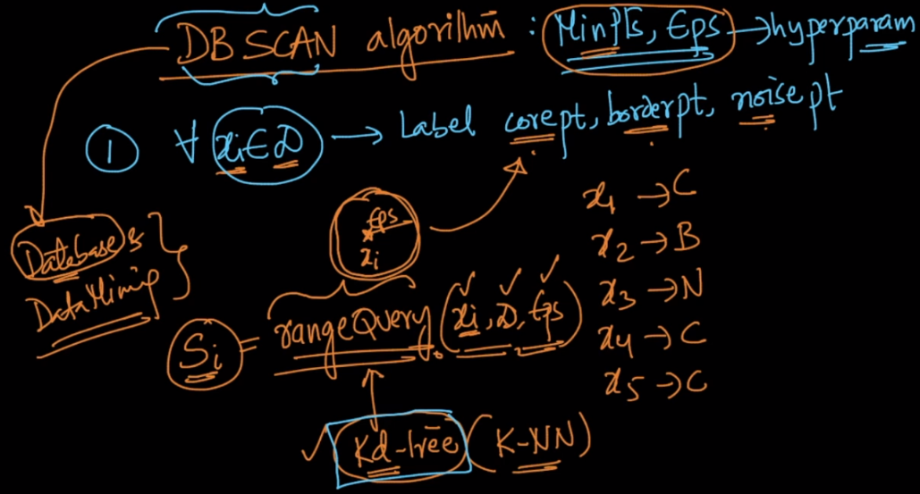

1. Remove all the points that are labeled as noise points(these noise points are sparse region), since they do not belongs to any cluster.
2. For each core point ‘p’ not assigned to a cluster do following things:
3. Create a new cluster with ‘p’
4. Add all the points that are density connected to ‘p’ to this new cluster.

Again to find density connected points to ‘p’ we need to use range query.

1. For each border point assign it to nearest core point’s cluster

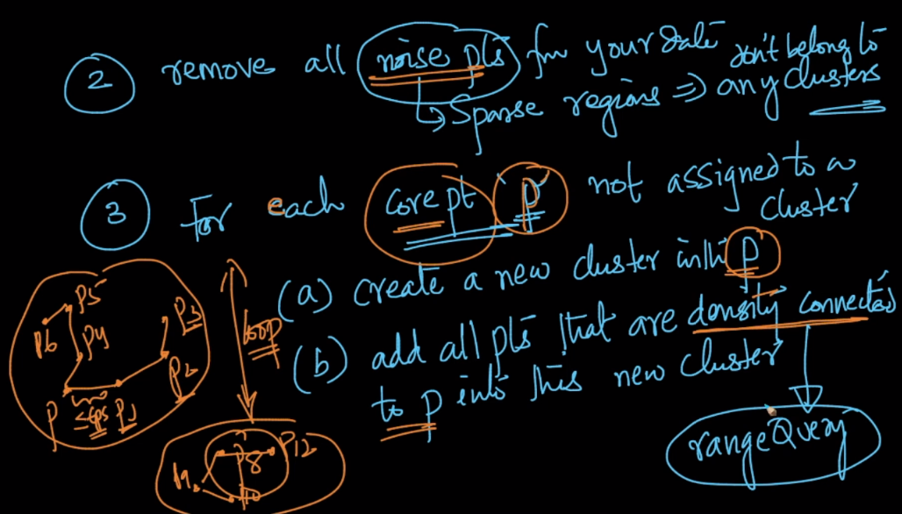

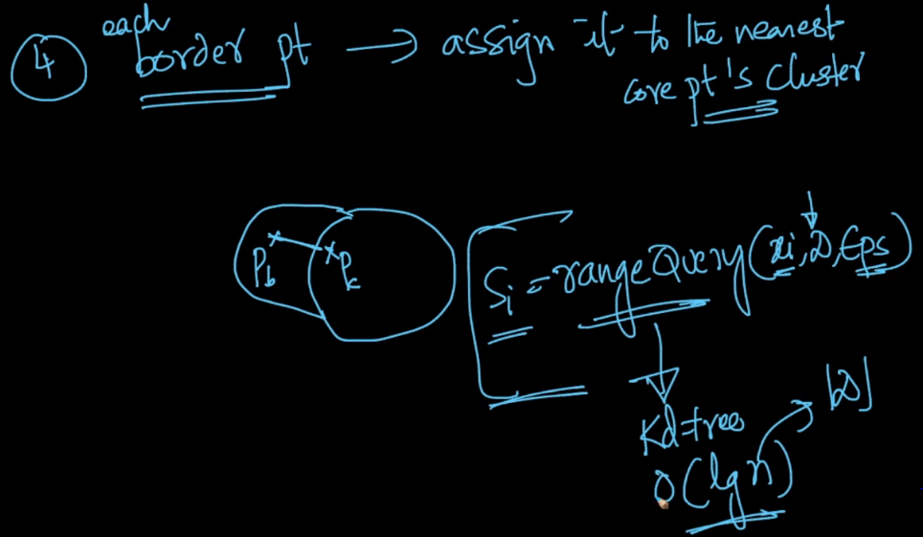

<https://medium.com/@elutins/dbscan-what-is-it-when-to-use-it-how-to-use-it-8bd506293818>

